1. Crear un proyecto base.
2. Crear la clase final DataBaseContract.java

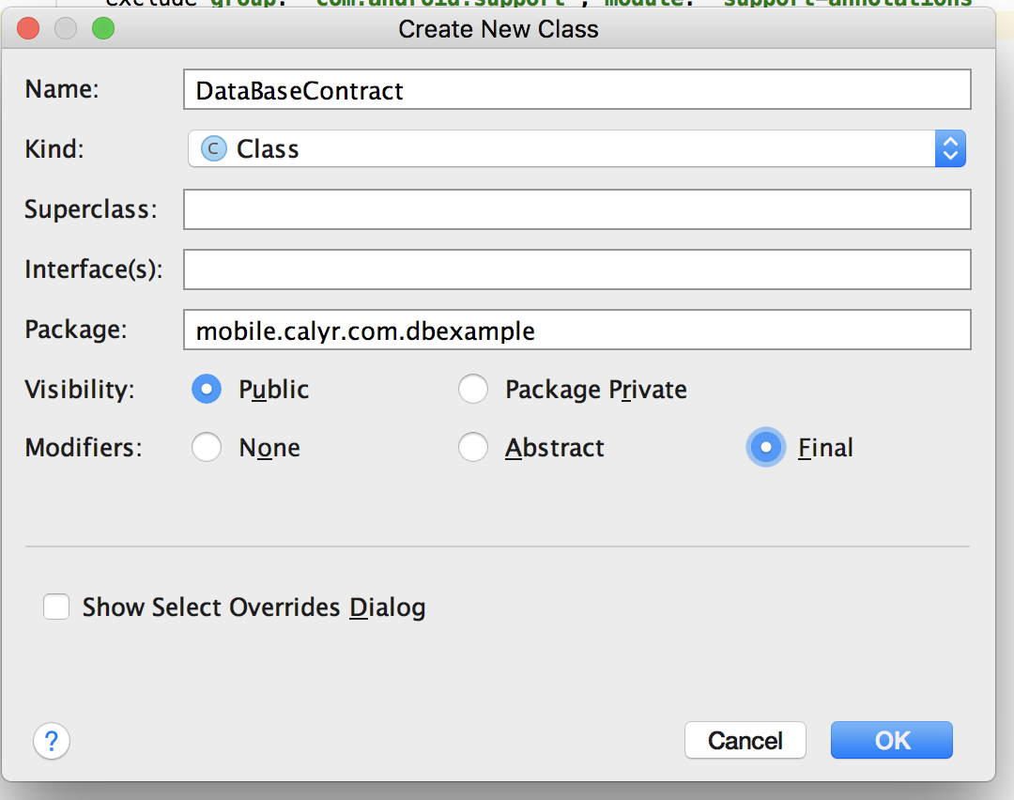

**package** mobile.calyr.com.dbexample;

**import** android.provider.BaseColumns;

**public final class** DataBaseContract {

**private** DataBaseContract() {} *// make non-creatable*

**public static final class** UsuarioEntry **implements** BaseColumns {

**public static final** String ***TABLE_NAME*** = **"usuario"**;

**public static final** String ***COLUMN_USER_ID*** = **"id"**;

**public static final** String ***COLUMN_USER_NAME*** = **"nombre"**;

*//CREATE TABLE*

**public static final** String ***SQL_CREATE_TABLE*** =

**"CREATE TABLE "**+ ***TABLE_NAME*** + **" ("**+

***COLUMN_USER_ID*** + **" INTEGER PRIMARY KEY, "**+

***COLUMN_USER_NAME*** + **" TEXT NOT NULL)"**;

}

}

3. Crear la clase DataBaseOpenHelper.java que herede la superclase android.database.sqlite.SQLiteOpenHelper

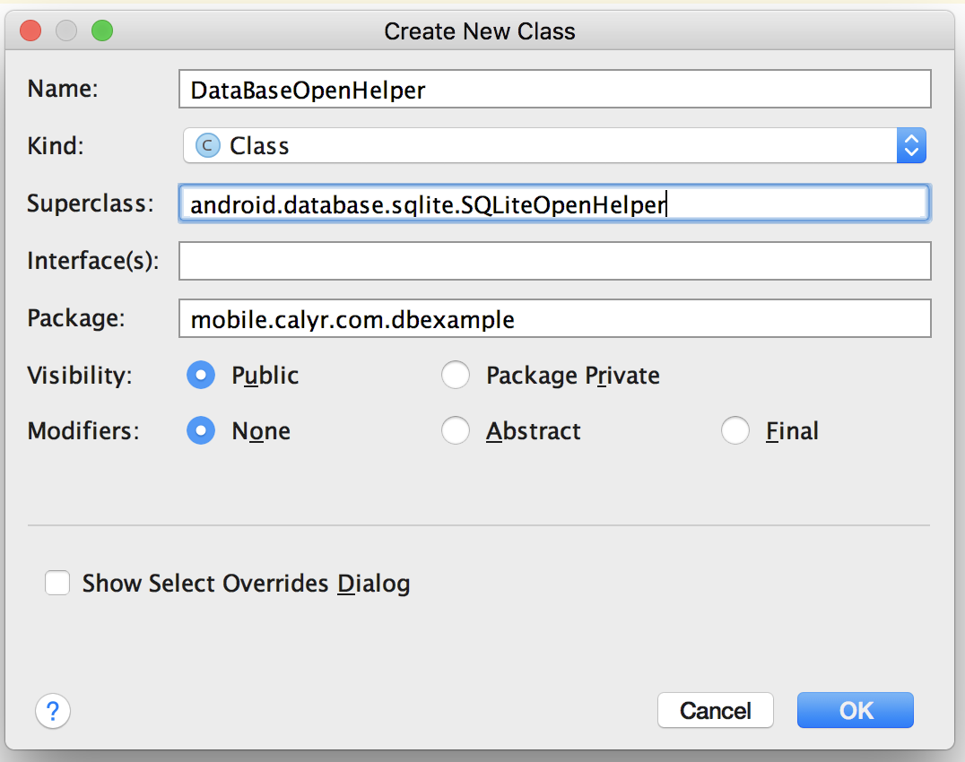

**package** mobile.calyr.com.dbexample;

**import** android.content.Context;

**import** android.database.DatabaseErrorHandler;

**import** android.database.sqlite.SQLiteDatabase;

**import** android.database.sqlite.SQLiteOpenHelper;

**public class** DataBaseOpenHelper **extends** SQLiteOpenHelper {

**public static final** String ***DATABASE_NAME*** = **"Usuarios.db"**;

**public static final int *DATABASE_VERSION*** = 1;

**public** DataBaseOpenHelper(Context context) {

**super**(context, ***DATABASE_NAME***, **null**, ***DATABASE_VERSION***);

}

@Override

**public void** onCreate(SQLiteDatabase sqLiteDatabase) {

sqLiteDatabase.execSQL(DataBaseContract.UsuarioEntry.***SQL_CREATE_TABLE***);

*//COLOCAR LA CREACION DE OTRAS TABLAS*

}

@Override

**public void** onUpgrade(SQLiteDatabase sqLiteDatabase, **int** i, **int** i1) {

}

}

4. Modificar la clase DataBaseOpenHelper y agregar los metodos de adición y listado.

**package** mobile.calyr.com.dbexample;

**import** android.content.ContentValues;

**import** android.content.Context;

**import** android.database.Cursor;

**import** android.database.sqlite.SQLiteDatabase;

**import** android.database.sqlite.SQLiteOpenHelper;

**import** java.util.ArrayList;

*/\*\**

*\* Created by robertocarloscallisayamamani on 5/10/17.*

*\*/*

**public class** DataBaseOpenHelper **extends** SQLiteOpenHelper {

**public static final** String ***DATABASE_NAME*** = **"Usuarios.db"**;

**public static final int *DATABASE_VERSION*** = 1;

**public** DataBaseOpenHelper(Context context) {

**super**(context, ***DATABASE_NAME***, **null**, ***DATABASE_VERSION***);

}

@Override

**public void** onCreate(SQLiteDatabase sqLiteDatabase) {

sqLiteDatabase.execSQL(DataBaseContract.UsuarioEntry.***SQL_CREATE_TABLE***);

*//COLOCAR LA CREACION DE OTRAS TABLAS*

}

**public void** addUser(String name) {

SQLiteDatabase db = **this**.getWritableDatabase();

ContentValues values = **new** ContentValues();

values.put(DataBaseContract.UsuarioEntry.***COLUMN_USER_NAME***, name);

db.insert(DataBaseContract.UsuarioEntry.***TABLE_NAME***, **null**, values);

db.close();

}

@Override

**public void** onUpgrade(SQLiteDatabase sqLiteDatabase, **int** i, **int** i1) {

sqLiteDatabase.execSQL(**"DROP TABLE IF EXISTS "** + DataBaseContract.UsuarioEntry.***TABLE_NAME***);

*// Create tables again*

onCreate(sqLiteDatabase);

}

ArrayList<String> getUsers(){

ArrayList<String> result = **new** ArrayList<>();

*//Select all query*

String selectQuery = **"SELECT * FROM "**+ DataBaseContract.UsuarioEntry.***TABLE_NAME***;

SQLiteDatabase db = **this**.getWritableDatabase();

Cursor cursor = db.rawQuery(selectQuery, **null**);

*// looping through all rows and adding to list*

**if** (cursor.moveToFirst()) {

**do** {

*// Adding contact to list*

result.add(cursor.getString(1));

} **while** (cursor.moveToNext());

}

*// return contact list*

**return** result;

}

}

5. Editar la clase MainActivity.java

**package** mobile.calyr.com.dbexample;

**import** android.support.v7.app.AppCompatActivity;

**import** android.os.Bundle;

**public class** MainActivity **extends** AppCompatActivity {

**private** DataBaseOpenHelper **mDBOpenHelper**;

@Override

**protected void** onCreate(Bundle savedInstanceState) {

**super**.onCreate(savedInstanceState);

setContentView(R.layout.***activity_main***);

**mDBOpenHelper** = **new** DataBaseOpenHelper(**this**);

**mDBOpenHelper**.addUser(**"Roberto"**);

**mDBOpenHelper**.addUser(**"Carlos"**);

System.***out***.println(**"Listando datos de la base de datos"**);

**for** (String name : **mDBOpenHelper**.getUsers()) {

System.***out***.println(name);

}

}

@Override

**protected void** onDestroy() {

**mDBOpenHelper**.close();

**super**.onDestroy();

}

}

6. Compilar el proyecto.

7. Para validar que se creo la base de datos, ingresar a: Tools -> Android -> Android Device Monitor.

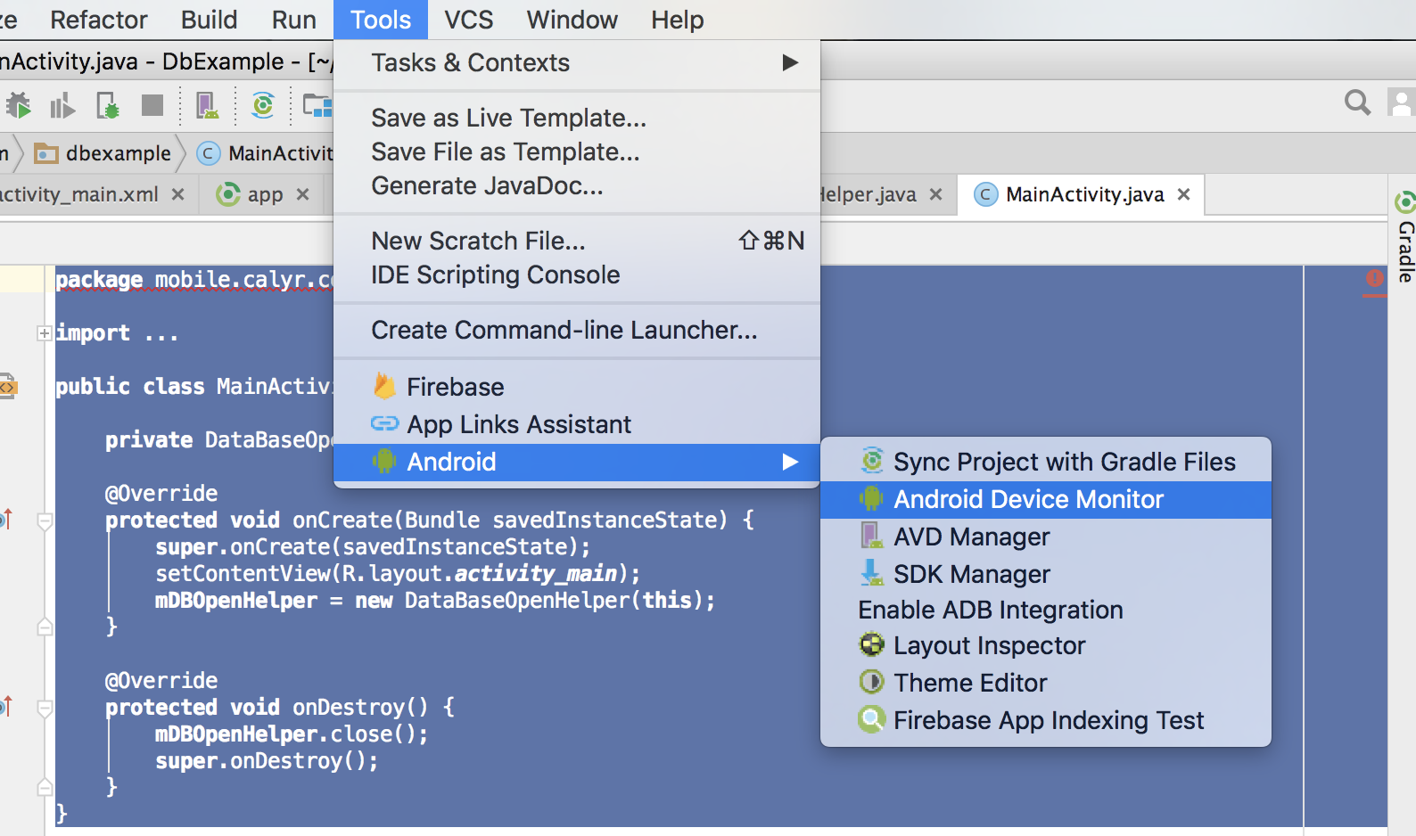

7. Ingresar al dispositivo de genymotion > File Explorer > data > data ( y buscar los datos de la aplicación ).

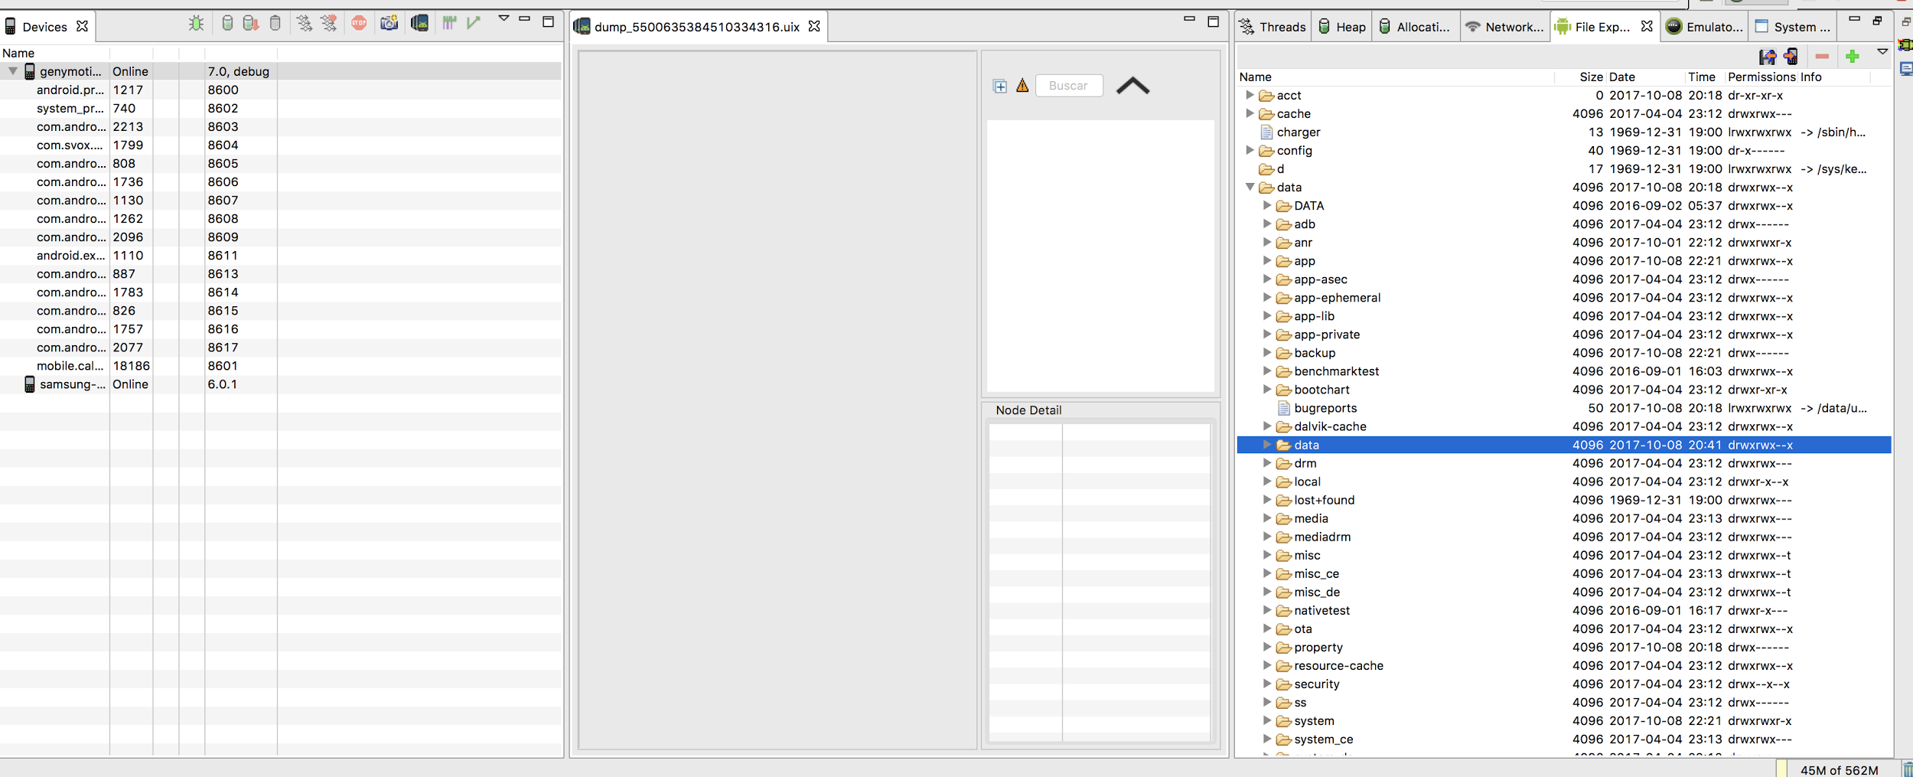

8. Para visualizar en la computadora se puede descargar (DB Browser for SQLITE)

<https://github.com/calyr/Sqlitebasic>